#13

BY

MICHAEL OSBORN FRANK

THESIS

Submitted in Partial Fulfillment of the Requirements for the Degree of

Master of Fine Art in Imaging Arts

Rochester Institute of Technology

_______________________________________________________________________
Willie Osterman, Chair Date

_______________________________________________________________________
Dan Larkin, Committee Advisor Date

________________________________________________________________________
Alex Miokovic, Committee Advisor Date

_____________________________________________________________________
Elliott Rubenstein, Committee Advisor Date

November 14, 2006

Acknowledgements
I wish to express my appreciation for the effort and input of Willie Osterman, Dan Larkin, Alex Miokovic, and Elliott Rubenstein. As a committee they supported my ideas and worked with me to insure they were articulated in the most effective manner. Individually they are friends and mentors who are enthusiastic pursuers of life in the philosophical and everyday aspects. I am honored to not only have worked with them, but to have grown through their presence.
A special note of gratitude to Myra Greene, Jeff Weiss, and Roberly Bell: who created so many opportunities for process and epiphanic moments of clarity to occur. I am most indebted, for without your presence the degree to which I began to understand myself and my art would not have occurred.
I would also like to extend gratitude to those individuals who have supported, challenged, and/or simply listened. My thanks to Sean Scheuble, Eileen Frank, Tom Frank, Cassie Worley, Sarah Webb, Susan Morelock, Aaron Bidwell, Matt Ghering, Jayson Bimber, Susan Morelock, Kelly Jacobson, Katrina D’Autremont, Bill Brown, Lily Daniali, Tom and RoseAnn Frank, Patti Ambrogi, Kurt Zeller, Lee Iannone, Sioux, The Classy Cookie and Deli, and Johnny. Your love and support is appreciated and reflected.
#13
By
Michael Osborn Frank
B.A., Studio Art, Santa Clara University, 2002
M.F.A., Photography, Rochester Institute of Technology, 2006

ABSTRACT
This thesis is an investigation into the nature of conceptual art and it’s existence in an increasingly secluded and digitized cultural. The context of this paper exists within a realm of academia and attempts to provide an intellectual setting for the installation entitled #12. During this examination the dissertation does not limit itself to a particular medium, but rather attempts to analyze imaging and art from a perspective that takes into account the interactive dichotomies and paradoxical notions that, as a society we not only create but define our existence.
As an artist I view the act prior to creation as harboring the greatest potential, and conceptual art as a continual investigation, which relies on the space of creation to give it context. In a literal sense this space is the physical place where the work is made manifest. However, the idea in the mind in this dissertation is viewed as an intermediary between the physical space and the nomadic nature of how work is presented. The extreme modes are important. They set up the typed word as an interactive moment where the viewer is allowed access and then denied the ability to interface with the concept.
Fitting to the context of the thesis, the word exists within an abstract and at times ambiguous mode of articulation that serves to raise a larger question. There is no conspiracy or divulging of beliefs, however, the moment one is forced to reconcile the reality with the idealistic virtue of a situation creates conflict. Fundamentally, this document asserts that this conflict is an opportunity to remove our self from isolation and allow for solitude. And within this solitude is our greatest potential for a transformative moment of introspection.

TABLE OF CONTENTS
List of Figures…………………….…………………………………..vi
Prologue................................................................................................vii
Interaction……………………………………………………………...1
Exploration……………………………………………………………..6
Articulation……………………………………………………………13
Transfromation………………………………………………………..19
Bibliography…………………………………………………………..21
List of Figures

Figure 1.1 God Game and Working Model Matthew Ritchie……….…………2
Figure 3.1 The Spectacle......................……………………………………….15
Figure 3.2 #12………………………………………………………………...17
Figure 3.3 #12………………………………………………………………..19

Prologue
The pedantic pedagogy of previous generations was a cultural aspect conducive to the creative process. The forms of the presented ideas are arbitrary, yet purposeful. As a reader we allocate substance to these forms based on years of focused training, which establish a means of interpreting linguistic ideas. After all this consideration the sentence itself may not mean anything. It could simply be a random assemblage of ideas. However, context alters our mode of consideration as it occurs in a paper that exists within the realm of academia. Additionally it is the first idea in this paper and we have placed emphasis if not on the sentence’s idea then the sentence itself. By now we have to reread the idea in order to situate our self in the discourse surrounding it. What may have been trivial is now the focus. At this point the sentence carries weight because there exist within the argument questions. The correctness or incorrectness is not the issue, but the idea has gained value and meaning because there is interest in how this situation exists not only in a generic sense but in a personal realm.
Initially one may have reacted to the loaded implications of pedantic pedagogy, generated questions for the argument, or considered particular circumstances where this idea would fail. In consideration of these ideas we might find the assertion absurd. Most importantly as readers we are able to discern the sentence says little at all. Similarly, the way we understand this paper has something to do with its specific context.
This paper exists in the particular realm of academia as well as, the realm of art, and specifically deals with the work of one artist. Therefore it is important to establish a focus inside a certain set of parameters. These boundaries do not define the essence of the art, but offer a vantage point, which allow us to argue the value of the statements made in relation to the work in question.

Interaction

I am proposing the idea that the perspective installed art provides is one that allows the opportunity for solitude. This idea is not to be mistaken with peacefulness or satiety, which are potential by-products of beautiful objects. In solitude with art I allow for introspection, emergence from that isolation, which initiates a confrontation with the self. In this moment there is a separation of intention and understanding, since actual interpretation is dictated by the set of ideas that the viewer projects onto the object.
I also propose that installed art is not a malleable medium. It cannot anticipate its destination, acceptance, or rebuttal. These actions are controlled by the variable positions of social interaction and include values (both economic and ethic), such as regional identity, market value, and international perception. Art in this context exists as a medium in a broader dialogical discourse where intention is diluted. Work is removed from its place of inception and creation and is often spoken for by someone else. In exchange these dialogic dimensions provide the opportunity for the artwork to contribute to a “greater” social and cultural cause.
A multi-intentional voice in art becomes an individual/social opportunity for rhetorical and reflective communication. The introspection it provides is the social counterweight to well-resolved endings, short attention spans, and quip advertisements. Looking to Matthew Ritchie’s work we can see an example of this methodology in process. Ritchie constructs installments of a privately created mythology, and offers the viewer opportunities to engage with elements leading to the creation of a personal universe. The interpretation of his work requires patience, large amounts of time, and an investment by the viewer, which potentially yields a new perspective on the interconnectedness and balance between singularities and universalities.
Fig. 1
Matthew Ritchie The God Game and Working Model

From a logical standpoint, the premise Ritchie assumes is controversial because the theory materializes into a transcendental philosophy. It would most likely receive heavy criticism from materialist and nihilist counterpoints due to the fundamental conflict in the nature of their respective arguments. However, that aspect is irrelevant because the presentation allows for personal beliefs to come into play. In other words, Ritchie has created his own realm, and is convincing enough that, regardless of whether the reader subscribes to the proposed philosophy or not, they must accept its existence in the world he has created.
As an audience we are able to extract from his efforts as an accomplished artist that he is able to coerce the viewer into accepting a rather irrational notion by offering the individual this compelling proposal. In this manner the installation allows for the circumstances that leads to the viewer’s interaction. In order for this to occur the artist must control the intention, and yet be open to multiple interpretations.
In The God Game and Working Model (see fig. 1) Ritchie uses charts, graphs, and data mappings, which are culturally familiar to us. A possible interpretation is offered to the viewer. It is the participant’s choice whether they apply it only to the current exhibition or to larger constructs. The individual’s decision is not the responsibility of the artist. However, as we will consider later, elements outside the work direct the viewer even if there is no intellectual meaning to extract, as we will see later.
The relationship of viewer/artist/object exists because the work has been or has the potential to be validated in the marketplace. Therefore we must consider the relevance of intention and meaning when art is considered as a commodity and how the commodification affects the interpretation of ideas. Let us assume for the sake of argument that a certain percentage of all artists represented by galleries have conceptually sound and intellectually situated pieces. However, when a collector is deciding whose work to acquire they are making an investment decision, and they have valid financial variables to consider. Some of those considerations are security of investment, cost, and personal taste. The artist’s intention may be included in that list, however there is no evidence to indicate that it is the primary reason for investment.
An artist’s intention thrives in the realm of academia, where individual themes are debated by intellectuals concerned with accessing the dialogue and concepts. This discourse of intentionality becomes an additional validating tool for artists. Here concept and process reign as selling points in the mental purchase. Intention is melded with concept and process to form a whole picture of the “romantic” artist, who seems to exist independent of the marketplace. As a result the purpose is analyzed, discussed, and made manifest in articles or research. It is a necessary position as this debate allows room for phenomenological discourse on the origins of the artwork.
Intention, as well as the artist, exist between the polarizing effects of the market and academia. Only in this space the fundamental nature of the artist is able to articulate a true presence in the work. This statement is not suggesting a balance between the two arenas. But a dialectic is necessary in order to generate a space that can impede the manifestation of a clear opposition between the arenas. Only the piece viewed in a raw, natural environment allows the potential for transparent interpretation.
At this stage art becomes a medium for the artist to understand his/herself and the world they are investigating. As a fundamental aspect of this discovery, illusion is a potentially counteractive device (unless the piece concerns the interaction with illusion itself). Olafur Eliasson points out “the reason you show the machine is to remind people they are looking”, which allows the viewer/participant to realize the potential for interaction is open-ended. There is no one-liner. If the viewer stares long enough, a 3-D hotdog will not appear; and since the viewers are being acted upon, they are not in control. There is no false pretense of discovery in art since it exists in a dialogical context.
If we accept this as an aspect of art, buying the piece can only bring one closer to the object. Ownership offers no further clarity to access the work. Likewise, neither does an article about the work. It only offers a perspective of someone who is qualified to talk about their experience. Understanding requires an introspective transformation and particular experiences, which harmonize the viewer and piece. The conundrum here is “the work never stabilizes, nor by extension can the viewer, they are both in a constant state of becoming.” As a result, the desire of the artist to understand the experience of a viewer/participant with their work it is unobtainable. Artists like quantum physicists can only gather snapshots of the evolution of interpretation, which prevents articulating the integration of viewer and piece.

Exploration

The current realm of virtual access to global infrastructure allows us to contemplate our existence relative to our perspective understanding of cultures around the world without traveling. The potential for instantaneous, long-distance interaction manifests itself daily. In our quest for answers we often tap into these societies, extract what we need, and attempt to transplant them into our own, familiar rituals. In this process the sponge known as our culture absorbs more and more of the world’s cuisine, exercise, diet, fashion, etc. As these numbers increase so do the ways we approach our idea of actualization. However, without full integration these approaches are a mask on the core being, which attempts to perform its rites without the community/culture of creation.
The process of actualization is further complicated by our relationship to community. In society we define and divide our community many ways: work, religion, hobbies, cooking, etc. These modes of belonging become an important reflecting point in our Western perspective. Kurt Vonnegut, in agreement with Alexis de Toqueville, says “in no other country other than ours has love of money taken a stronger hold on the affections of men.” As a value, in this context, finances become a tool for selecting and utilizing community.
By dividing and subcategorizing community we make specific statements about the individuals of our culture. Through these actions we define our self as composed of multiple communities, instead of belonging to an overarching community. (We could debate the idea of statehood or nationality, but I’m separating those ideas because we cannot alter our participation in them almost instantaneously.) As a result, we don’t integrate fully into these communities, however, we propagate the language of these institutions in order to garner greater social status. The chosen traits and values are used to delineate us as individual and unique. The shifting declarations create plastic identities, where we utilize the person we most need to be for the moment it is most appropriate.
A plausible argument involves this interchangeable identity being developed aggressively and early as means to achieve successful status. These identities within communities begin earlier, however an example is articulated by university guidelines for admitting new students. Emphasis is focused on the “well-rounded” individual as defined by the institution. Pressure is furthered during education with a focus on “networking” in order to attain better employment, and one could even suggest whole communities are created in order to facilitate this action. During this patterning, by creating an illusion of logical steps to success, we simultaneously construct layers of separation in our society.
Equally important, the flow of our social construct is conducive to the community contributing to the individual. Part of this result is the focus of our culture on individuality as accomplishment. Our perspective develops in a culture that emphasizes this socialization and permeates our consideration of global identity.
The attainment of material possessions creates further complications. Accumulation in this sense can either be considered a symptom or an accomplishment. In the state of accomplishment it honors the individual as a capable and successful procurer. It is logically simple to assert how leading a better life is built on the ethics of hard work and “good” values. Ethics are presented as a material medium. Quantity of possession is metaphorical of values and ethics. “Beating the Jones’s” is not simply about quality of life but displaying this value set.
The accumulation, especially noted in pop culture, becomes symptomatic of individuation taking place. As a result the community bonds build on the individual desire to attain this status. Status becomes another commodity in a brand culture where names can be bought/sold or used to further the appeal of a product. This self-imposed caste system has an underlying capitalistic flow as individuals are granted and denied access based on their “bling-bling” and the supporting network they have established. As a result the community becomes plastic, molding to fit the individual’s needs. The language and customs of that culture become transient, dictated not by the group but by the person who has most recently arrived at the top.
The malleability of the language and shifting focus in this culture make speaking to the whole (the community of attainment) increasingly complicated. However one shared experience is, as members of this community, we have mental diversions as a point of reference. We are able to hold our own desires and moments of attainment as personal case studies. For the artist, these personal studies become steeped in our own layers of experience, and unless we offer a key for deciphering, such as Ritchie does, it becomes intellectually inaccessible.
The antithesis of this social context is best represented by the legendary Japanese director Akira Kurosawa. He uses the cultural language of his community to convey certain themes without didactically pointing them out. Outsiders to these films need a verbal translator and a cultural one. Kurosawa speaks to the entire society instead of creating a niche market. This occurrence lends itself to the potential for universality of meaning. As contemporaries and outsiders we look at how these films are situated historically and attempt to translate this realm of experience. The resulting visuality of his epics lure the spectator into a mode of discovery and transformation. In this manner Kurosawa connects so intimately with his cultural identity the layers become accessible from a passionate embrace as opposed to a logistical key.
Neither attainment nor universal language used as a means of creative exploration has greater value. They are interactive dichotomies indicative of modern culture and the potential aspects the artist can utilize. As initiators of this dialogue our parameters for communicating with audience are defined, and as creators we must manipulate these tools in order to communicate with the viewer.
Utilizing the context of this paper I have organized these ideas using a flow chart as a guide. Here the logic begins to break down and all routes lead into a pool. In this pool the elements are subjective and plastic, flowing into each other in a cyclical exchange of the conceptual. Through this transition we access the liquid foundation of conceptual art and the necessity of its invention as a communicative process. In other words we must make an illogical leap not only ideologically but in reality in order to best attune ourselves to this mode of creation.
“Conceptual Artists are mystics rather than rationalists. They leap to conclusions that logic cannot reach.” The position of a Conceptual Artist in our society is a paradoxical notion. The artist in this context is building an object or form, representative of ideas that one cannot own, and presenting them to an audience intent on attainment. This action is not equivalent to the tailor selling the emperor invisible clothes. Instead it proposes a way to communicate on a much deeper level with greater ramifications.
Success of the experiential in art would provide proof for a theory of a unifying cosmological cord that runs through all beings, since it uses illogical circumstances to communicate with a logic oriented audience. The existence of this cord will never be photographed, however the attempt to access it represents the mystic merit Sol Lewitt accredits to the Conceptual Artist. They are shamans of a scattered culture. This point suggests they are guides attempting to find meaning for their self and simultaneously provide access for others. The obvious counterpoint is to site unsuccessful works, but the fallacy here would be to assume that any one has arrived. In other words if we consider these exhibitions experiments in the experiential then a truly successful piece could potentially create a transcendent moment not only for the artist but also for the viewer, and quite simply there is no way to quantify this act.
Abstraction and minimalism are essential developments in this journey. Their sparse nature is indicative of this common cord. Physical elements become additional information in a layered society that potentially distract from meaning. Minimalism removes illusive devices and pushes the intent of a piece to speak. The complementary movement of abstraction allows for the illogical to situate itself in this argument by creating porous boundaries (though abstraction can be extremely logical in its construction). Additionally it asks the viewer to connect with the artist, returning to the potential for a transformative moment of introspection.
Ultimately a value statement (not simply monetarily but ideologically) is at stake during this discourse. The marketability of the object is pitted against the transcendental potential of its idea. The potential to work through these ideas is intrinsically tied to the ability to procure funds for such discourses. Here the process to liberate the idea from its physical constraints begins. The Conceptual Artist in this quandary has to subscribe to the equality of form and utilize it to articulate the specific nature of existence. Otherwise the artist is simply making pretty objects for sale and intention is about sustaining instead of exploring, and the individual fails both the intellectual and buyers market, as capital and exploration are historically intertwined. The act of exploring/delving suggests some appropriation of a divine/spiritual idea. Regardless it lends itself to the potential for formless work, as Lewitt may have foreseen a future when he wrote “Ideas alone can be works of art; they are in a chain of development that may eventually find some form. All ideas need not be made physical.”
Fundamentally we can describe this flow as a search for origin, where understanding and truth would reside. The more layers we remove, the closer we get to process, and the origin of concept where the elemental surface becomes exposed. Through such experiments we can approach this ethereal moment of being. The value judgment of the artist is defined in this context through the necessity to part with attained goods and let go of arbitrarily chronicled history; in this experience exists the potential to perceive the present moment as important as the whole of previous existence. This lateral equalization of time lends weight to any action and simultaneously subtracts all importance from its occurrence.
The artist here is liberated from formulaic constraints that potentially divide him/her from the ritualized process of creation. The state of existence here, in its optimum, links the artist to the primal community through ritual. The ritual is different than the formulaic as it allows for an epiphanic moment. In contact with this elemental one, communication is a divine prosprieter of creation and the notion of the “individual” ceases to exist. From this state of existence and creation, the potential for true community, representing One, flourishes, and individuality is relegated as nothing more than a mask.

Articulation

One of the Conceptual Artist’s possible strategies is to remove layers between the artist and viewer rather than building or modifying them. Utilization of this method requires an understanding of how art facilitates a transformative act of introspection, and the ramifications of that occurrence in a society focused on individuation. The continuation of this consciousness is indicative of a successfully established dialogue with the Self. And in the realm of conceptual art, this conversation thrives through experimentation and failure, no one experiment is more important than the other.
In my experience these experiments have developed gradually. They began while I was primarily communicating through a photographic medium. In Mother, Sister, Daughter I utilized wall space and mural prints to create an atmosphere that enveloped the viewer. The act of entering the space became a performance and required the viewer/participant to be present in order to complete the piece. This moment would be my first encounter with installation.
This personal development in image making and visual culture enabled me to depart from this process and experiment rashly with a multitude of materials. There was no rationale or concept to this experimentation except a search for a way to communicate that moved beyond my traditional five senses. However, the foundation in a philosophy of image making grounded this process and provided a tethering perspective. From these links I began an investigation into how images describe us, the image maker, and communicate with the viewer.
Initially I used pastels and photographs to represent different dimensions of person and the mental spaces/physical apparitions we allow to be presented and hidden. Mentally enveloped by the first investigation I attempted to have two dimensional elements define a three dimensional space. The potential for this is entirely plausible, however in this context it allowed for too many suppositions by the viewer. As a result of the variables, some viewers were unable to immerse their self in the encounter and participate in this installation. There were also problems with the dialogue. For example, even for people who were able to enter the piece; layers were dense and personal, there was no key from which they could construct an interpretation.
The experience of this piece was an integral contribution to understanding the ramifications of a validated process and how that affects the product. I realized the importance for an artist to control the variables. The further the object was removed from its place of creation the more direction the audience had to be given, in order to access its intention. Therefore, if the viewer doesn’t come to my studio and view the space of creation then I have to work harder to translate the moment of inception visually. If that process succeeds then I can allow the interpretation to be the viewer’s creation, as it relates to the truth of their self.
The follow up to this experiment was an endeavor to control the environment as intimately as possible. I decided the best manifestation of this effort was to create spaces that encapsulated the participant and were small enough to confront them in a direct manner. To highlight this sense I created for the participant the feeling of being watched so they would elicit particular responses.
Installation View The Spectacle
The construction consisted of four booths that were 3’ x 3’x 7’. This size made them portable, and allowed the properties of the space they were created in to travel. It also limited potential movements of the viewer, and forced them to confront the pieces on a personal level. All the booths had doors and opened/closed in accordance with a particular theme: equivalents, actualization, body, surveillance. In order to accentuate the feeling of being watched I installed surveillance cameras in prominent visual positions, except one of the booths. This booth did have a camera and, in addition, a television where you could watch the other participants.
The order of entering the booths was participant’s choice, which provided a sense of freedom in this fully contrived environment. It also allowed for the interpretational values of the dialogue to exist in a continually developing interaction with the self, instead of imposing an unnatural order on the viewer’s inclination. The results in this scenario were more affirming than in the previous experiments, however they still had one problematic holdover from earlier work.
Everyone seemed to access the concept, and it was the closest to a successful interaction as I had created. Again though, the imagery and ideas presented were personally layered, positing even a well-educated audience with insurmountable barriers. The problem was not that the leaps were illogical, they were logical in a narrative sense, except they relied on a personal weaving of experience, reality, and expectation, which created ambiguity. In other words it could not be referred to as “it is what it is” as it left too many unanswered questions. And though it appeared decipherable it alienated further pursuit by the audience.
A transformation of process occurred next, when I attempted to engage the subconscious realm. It is the analysis of this shift that commences investigation into this development and situates it in a dialogue to debate its communicative merits. The titles of the pieces in this series are numbers. These serve as a guide to the viewer as an indicator of chronology, though arbitrary in nature. The numbered installations together have no significance except the order in which the objects were potentially created. The order is noted because it gives lineage to the evolution of the communication process. However, the numbers have no value significance. New manifestations of previous exhibitions created down the line will have the next number in the sequence.
The significance of numbering and removing emphasis on “the product” adds balance to the objects and shifts focus to the process. Hypothetically, if all objects were to be exhibited simultaneously then, much like a retrospective, we could view the continued process of creation. However, we would be applying the process to a specific body of work concerned with exploring the communicative aptitude of its concept.
With the idea of the present moment being as important as the whole of previous existence, this numbering model becomes a metaphor to expound on the present. For example if an installation 800 square feet is given the same significance as an aluminum cube 5” square then focus is shifted to concept and process balanced by the object. Delving into the present moment becomes our primary focus, but its “newness” is a temporary trait and eventually will hold the same value as all other moments. However, the sum of all these moments is not more valuable than the moment we tap into the cosmological cord. In that instant time is not a defining factor, and its plane of direction is not something we must confine ourselves to live within.
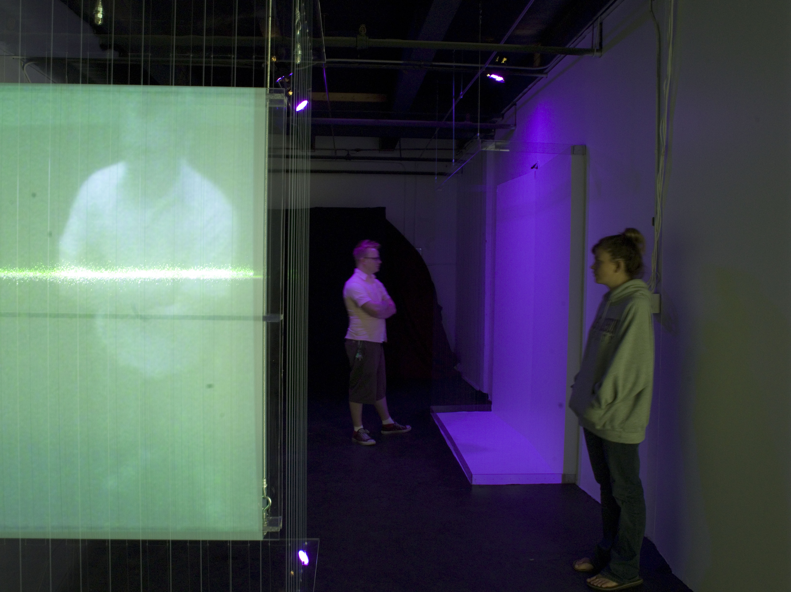Installation View #12
#12 serves to address this issue by presenting the viewer with an interactive installation that provides boundaries and interpretative perspectives. The elements of the exhibition are pared down to fundamental elements of light, color, and geometry in order to prevent “loaded implications” via the materiality of the piece. The minimal elements also push the viewer to accept self as an integral part of the exhibition and question their placement in relationship to the objects.
In order to accentuate this experience a limited number of individuals were allowed to view the piece at any give time. This situation places the viewer in specific relationships not only with the objects, but the other participants. Other relationships addressed in this exhibition include interior and exterior, perception and reality, self and memory. However these are merely portals for accessing the intention of the work, as it is the ultimate aim for the viewer to exit with a shifting perceptual dialogue.
Upon entering the exhibit the viewer encounters two squares made of aluminum boxes and red light. These stem directly from a discourse of Josef Alber’s work and serve as a conceptual map for the viewer. Regardless of their knowledge of Albers, one should be able to extrapolate the literal allusion to perception/spatial interaction. It also serves as a visual cue to the artist statement allowing the viewer to interpret the essence of the piece without having to be verbally constricted.
Continuing through the exhibition the participant will encounters a space enclosed by monofilament and polycarbonate. Here their image is transferred via surveillance camera to a monofilament/polycarbonate structure on the opposite side of the room. The individual is projected into a space they cannot access and will never be able to fully visualize.
In the final room of the exhibition the viewer leaves the minimal light of the previous room and enters an 8’ x 8’ x 8’ cube that is solid white. It is lit by nine daylight balanced fluorescent lights, has two normal exterior walls, two fabric exterior walls, and an interior booth 3’ x 3’ x 8’ made of plastic sheeting and sand. They are able to step inside and even enter the plastic sheeting where the exhibition is at its most sterile. Inside this booth they are standing on sand, and leave footprints on the white floor. These footprints increase to show the potential existence of other individuals in this space, a similar probablility of experience.
Exiting this piece the viewer returns to the darker space. A shift of the pupils occurs, as well as a disorienting effect. At its greatest potential the viewer will arrive home with sand in their shoes to continue the dialogue as they shake it out over their backdoor. In a more obvious sense the viewer experiences color shifts almost immediately between the daylight colors, the darkness, and the industrial lighting of the studio building. However, the greatest potential for understanding occurs only for the viewer. The artist is too close to the materiality of the exhibition to absorb the experience creating a simultaneous exchange of access and denial between the installation and the viewer and the viewer and the artist.
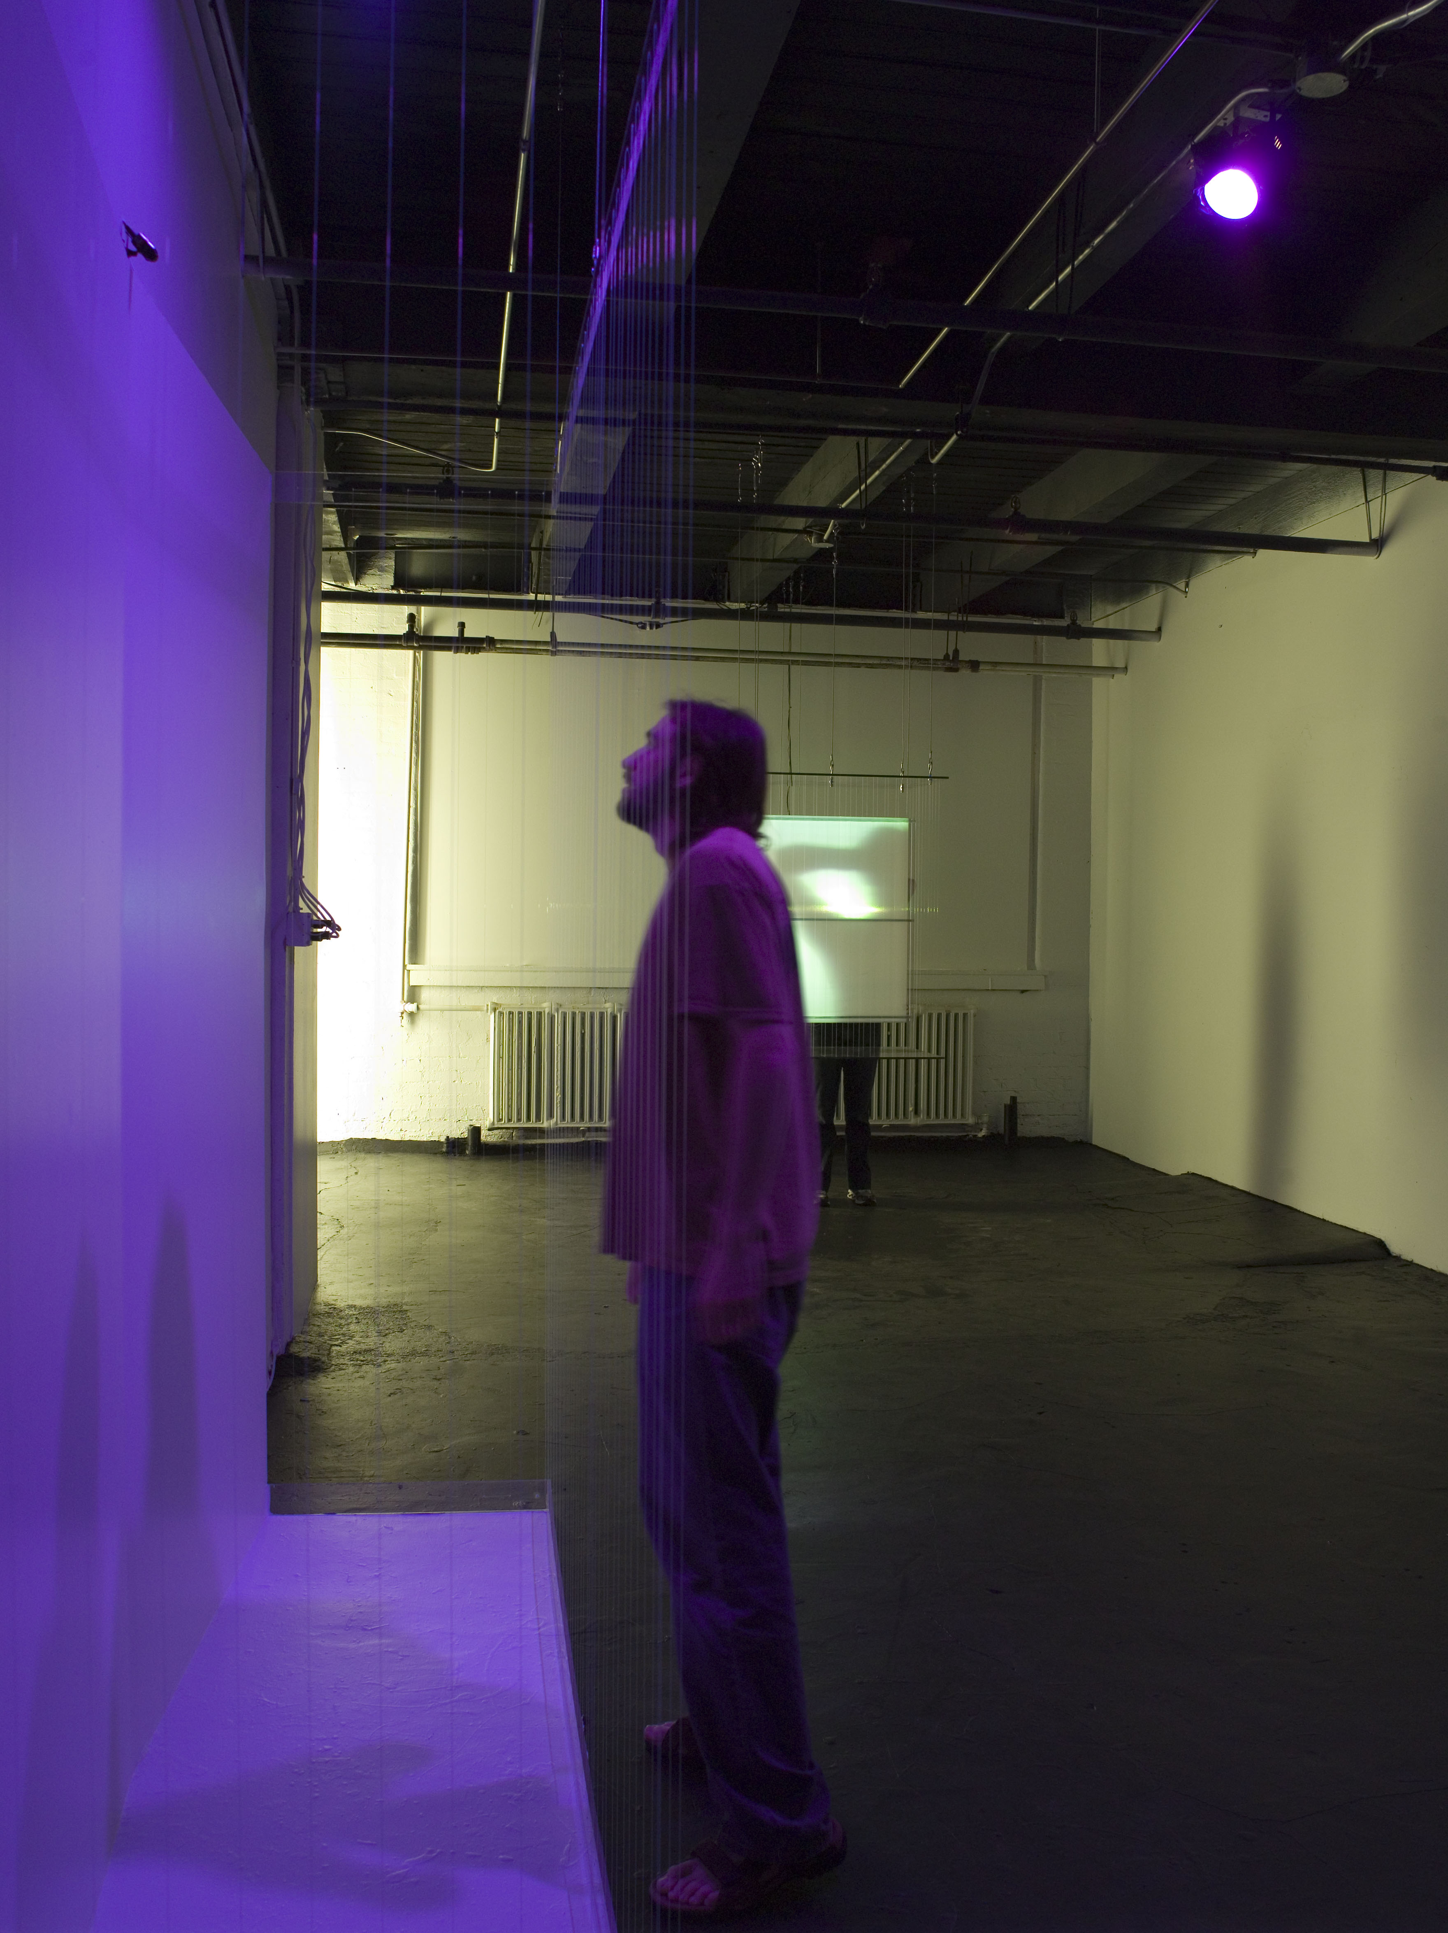#12 Installation View
If we were to view this from a physics standpoint, we would consider the saturation of energy, and if it was considered a number this value would remain constant. In this circumstance there is no actual attainment, there are simply subtle movements within greater spheres. Through this theory the installation in process now offers that potential for shifting. The viewer in motion is in dialogue with themselves, in pursuit of energy, and excising barriers to understanding, with good reason. Because, if we extrapolate the potential in this theory then everything and nothing at all is at stake in that very moment. The potential will supersede the actuality at any given moment, it has to as long as we remain physical entities.
Transformation
As we assign arbitrary values to objects and individuals we steep ourselves in an illusion of dissonance as opposed to minimizing in search of a unification. Conceptual Art as a product of Imaging Art as a product of questioning has the innate potential to balance existence. Through the process of its creation it has the ability to compound the complexities of contemplating existence. Neither has a greater value as they are both products of an elemental One, however the ramifications for communicating and the perceived potential harbor a desire to explore.
On the existential scale this entire argument becomes irrelevant, however in this transformation the existential perception is a potentially valid view as to the nature of being. Regardless as to the viewpoint one subscribes to, there is a desire within to explore the possibilities of our creative outputs. These creative outputs though give us the inverse ability to explore the dialogue of their inception and the value of these desires.
Only the persistence of the artist to let go will facilitate this reckoning, as the release of the desire occurs simultaneously with its manifestation. Otherwise, in order to accomplish it we must build layers which prevent access to truth and there is only the opportunity to confront the reality of another truth, which is why image as illusion is so preferable. Image of the moment allows for a satiated experience.
It is easy in all of these processes to be bound into a cycle of formulaic creation. However, by investigating the origins and communicative sources we are building, the formulaic is quite literally transformed into ritual. It becomes imbued with meaning. There is no place in this equation for the existence of the banal or mundane, not because they can’t be pertinent elements or tools to facilitate experience. However each moment exists on a cusp of an epiphanic experience, which is anything but boring, and each creation becomes a new step in the exploration where these elements surround us, and they are all brimming with potential to manifest truth.

Bibliography

Bishop, C. (2005). Installation art : a critical history. London, Tate.
Freire, P. (2000). Pedagogy of the oppressed. New York, Continuum.
Gilman, C. P. and E. Hedges (1996). The yellow wall-paper. New York, N.Y., Feminist Press at the City University of New York.
Grynsztejn, M., E. Olafur, et al. (2002). Olafur Eliasson. London ; New York, NY, Phaidon Press.
Harrison, C. and P. Wood (2003). Art in theory, 1900-2000 : an anthology of changing ideas. Malden, MA, Blackwell Pub.
Kroeber, K. and C. B. Kroeber (2003). Ishi in three centuries. Lincoln, University of Nebraska Press.
Kwon, M. (2002). One place after another : site-specific art and locational identity. Cambridge, Mass., MIT Press.
LC Off-Air Taping Collection (Library of Congress) and Copyright Collection (Library of Congress) (1992). Ishi, the last Yahi = The American experience. Ishi, the last Yahi Indian. [United States
United States, s.n.]
PBS: 1 videocassette of 1 (ca. 60 min.).
Martel, Y. (2001). Life of Pi : a novel. Toronto, Alfred A. Knopf Canada.
Meyer, J. (2000). Minimalism. London, Phaidon.
O'Doherty, B. (1999). Inside the white cube : the ideology of the gallery space. Berkeley, University of California Press.
Osborne, P. (2002). Conceptual art. London ; New York, Phaidon.
Reiss, J. H. (1999). From margin to center : the spaces of installation art. Cambridge, Mass., MIT Press.
Richards, J. O. and Independent Curators International. (2004). Inside the studio : two decades of talks with artists in New York. New York, Independent Curators International : Distributed by D.A.P./Distributed Art Publishers.
Rilke, R. M. and J. J. L. Mood (1975). Rilke on love and other difficulties. Translations and considerations of Rainer Maria Rilke. New York,, Norton.
Smith, C. (2001). Home Movie. United States of America, Home Vision Entertainment: 60 minutes.
Sollins, S. and M. Sollins (2003). Art: 21 : art in the twenty-first century. Vol. 2. New York London, Harry N. Abrams.
Storr, R., L. Bourgeois, et al. (2003). Louise Bourgeois. London ; New York, Phaidon.
Vonnegut, K. and D. Simon (2005). A man without a country. New York, Seven Stories Press.
Warr, T. and A. Jones (2000). The Artist's body. London, Phaidon.
Weintraub, L. (2003). In the making : creative options for contemporary art. New York, D.A.P./Distributed Art Publishers.

Rilke, R. M. and J. J. L. Mood (1975). Rilke on Love and Other Difficulties. Translations and Considerations of Rainer Maria Rilke. New York, Norton. p.27
Warhol allowed for this shift of context outside of the studio. Frequently in interviews he would agree with the interviewer’s statements about his work regardless if they were right, and even if they were diametrically opposed to a previous interviewer’s thoughts. A part of the rationale being that someone else would be speaking for his work the majority of the time, and in that sense shouldn’t they be “right”, even if they were “wrong”.
Weintraub, L. (2003). In the Making : Creative Options for Contemporary Art. New York, D.A.P./Distributed Art Publishers. pp.52-62
In this instance I am aware that the proposed idea is being set up so that it can be dismissed. However, this negation of conflicting ideas based on the shifting of the context of argument and the paper’s concepts about installed art.
Irrational in this context does not carry a negative or unfounded connotation. Instead it is used as a counterpoint to systematic observation and extraction, more in line with Sol Lewitt’s Sentences on Conceptual Art.
Weintraub, L. (2003). In the Making : Creative Options for Contemporary Art. New York, D.A.P./Distributed Art Publishers. pp.52-62
Concerns the intellectual sell of an idea to patrons, buyers, or students in attempting to grasp the conceptual idea at hand.
Environment in this sense refers to the unsterilized origin of creation. In this state both the aura of the object and the creative context remain in tact.
Defined as the ability for the viewer to extend beyond the object or surface and enter into a state of processorial understanding where intention is accessible.
Olafur Eliasson Grynsztejn, M., E. Olafur, et al. (2002). Olafur Eliasson. London ; New York, NY, Phaidon Press. p.14
Ibid. p.67
Vonnegut, K. and D. Simon (2005). A Man Without a Country. New York, Seven Stories Press. p.8
Alumni, Fraternities, Sororities, etc.
This is a common slang term referring to ostentatious clothing or jewelry and the wearing of them.
This community is not limited to tangible possessions. As asserted earlier collecting “cultural traits” and other exotic experiences is implicated as well.
Specifically in the film The Seven Samurai, one of the samurai has his head shaved in order to aid a villager. For an outsider this is a minor act, however this action is used to describe the qualities of the character and would have been immediately understood by a Japanese audience.
Lewitt, Sol. “Sentences on Contemporary Art,” 0-9 (January 1969): 4; reprinted in Art Language I (1969): 11-13; and in Ursula Meyer, Conceptual Art (New York: Penguin 1972), 174-75.
Ibid. p. 11-13
By establishing a dialogue with the Self then we are communicating via the cosmological cord. As a dialogue with this greater Self expands to a primal origin then consciousness is expanded.
Santa Clara University Student Gallery, 2002.
Essentially, this provides for an illusory position of control, which is a temporal relationship inversely proportional to the amount of the installation the participant has completed.
As physical entities we are limited by the effects of environmental conditions such as gravity, temperature, etc. Included in these issues are methods of communication, which are defined by means that take some type of physical input/output, in other words time. They also require visual and audible clues in order to take place which exist in time. Therefore immediate conveyance of thought cannot occur in the present moment, and the exhibit at hand has the most potential in its inception. It is there that nothing has been ruled out or edited out. The tangible form can take any route of progression and will, at this moment, not direct the artist experience in future articulations of this idea.

